1. Database Modelling (5 Marks)
Design an E-Commerce Database Model
a) Develop a data model suitable for an e-commerce application that includes at least three entities.
b) Your model should clearly show the entity names and attributes for each table.
c) Your model should clearly show primary keys and foreign keys, where appropriate.
d) Your model should clearly show the relationships between tables (one-to-one, one-to-many, many-to-many), indicating how they connect and enforcing referential integrity.
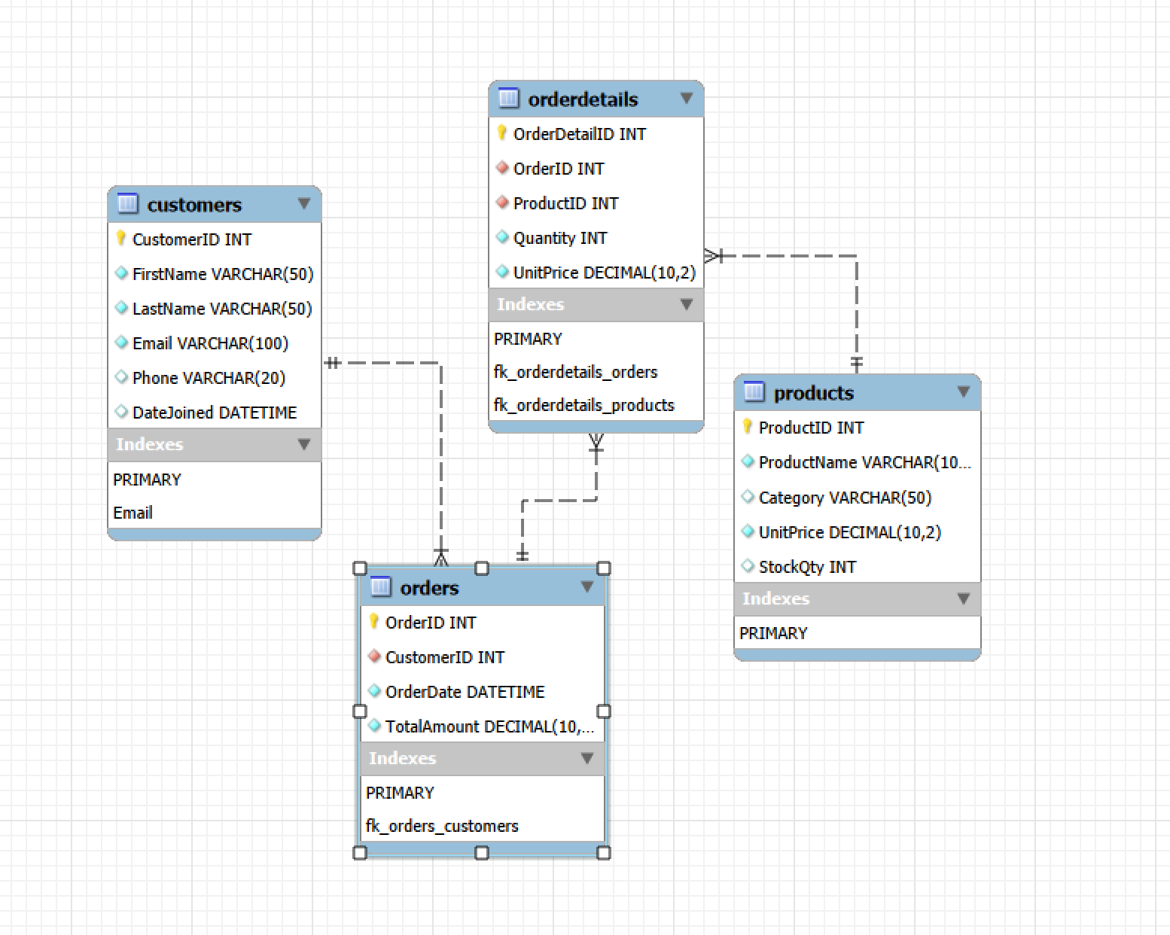

2. Basic SQL Queries: Execute CRUD Operations (5 Marks)
Write SQL statements for the following tasks using hypothetical data from a typical e-commerce database:

Insert a new customer record in the Customers table.
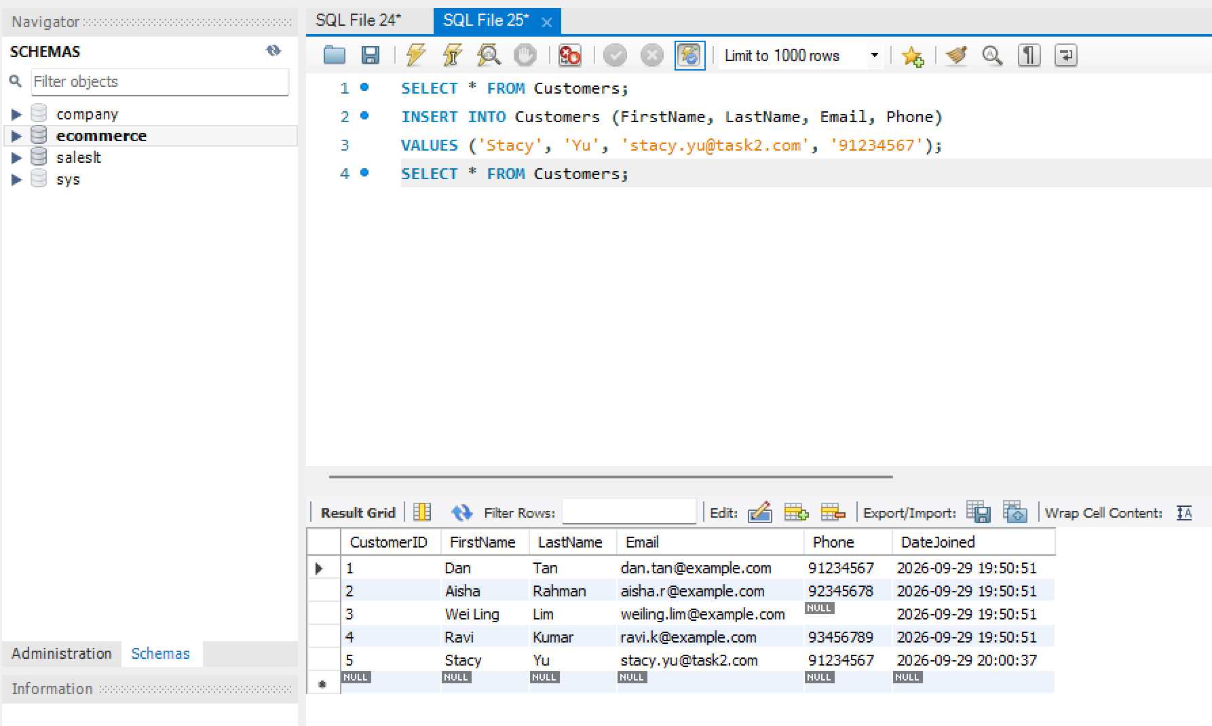

Update a customer's email address based on their unique CustomerID.

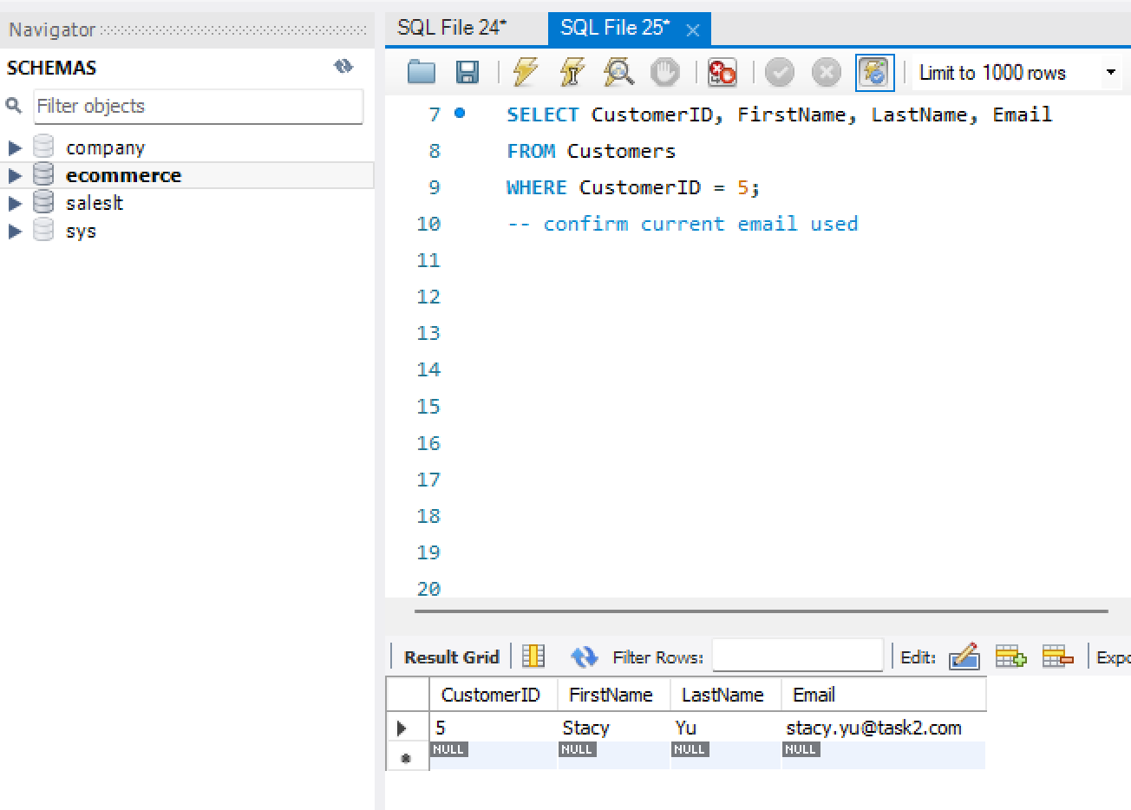
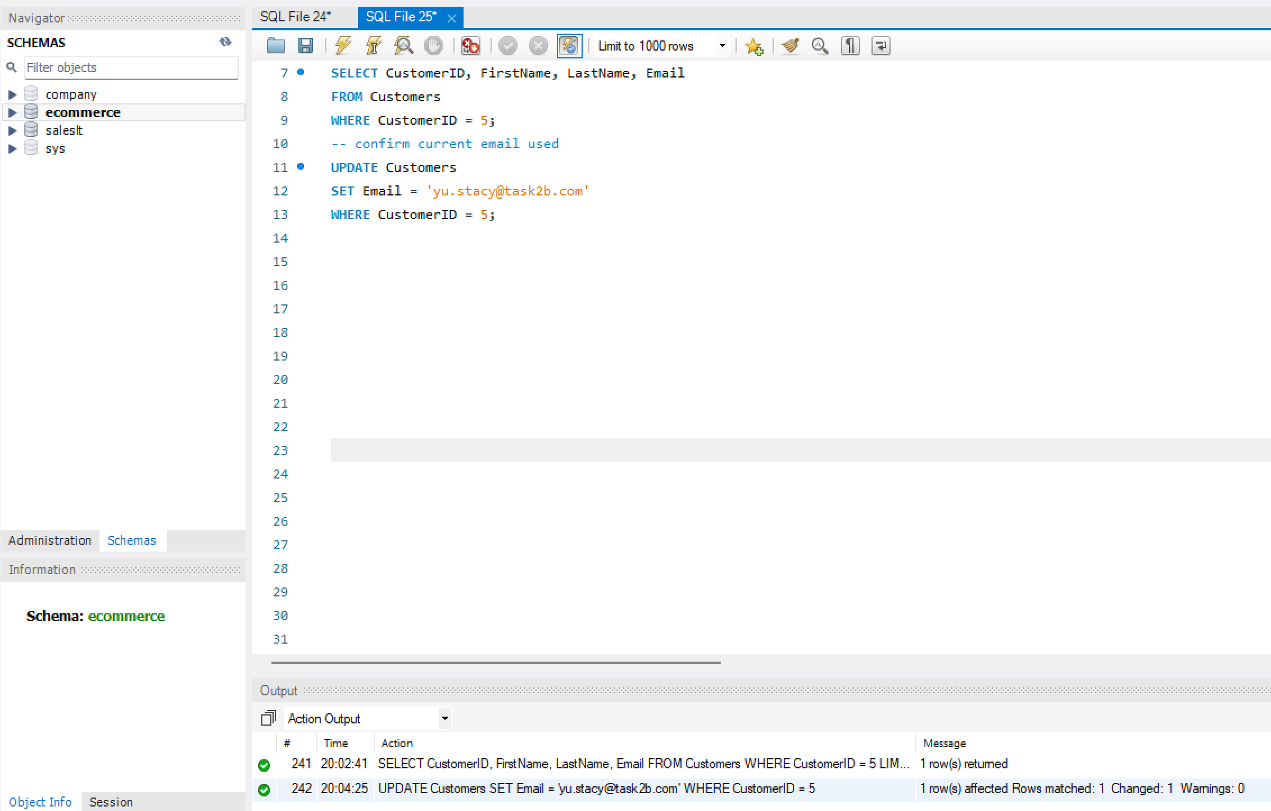
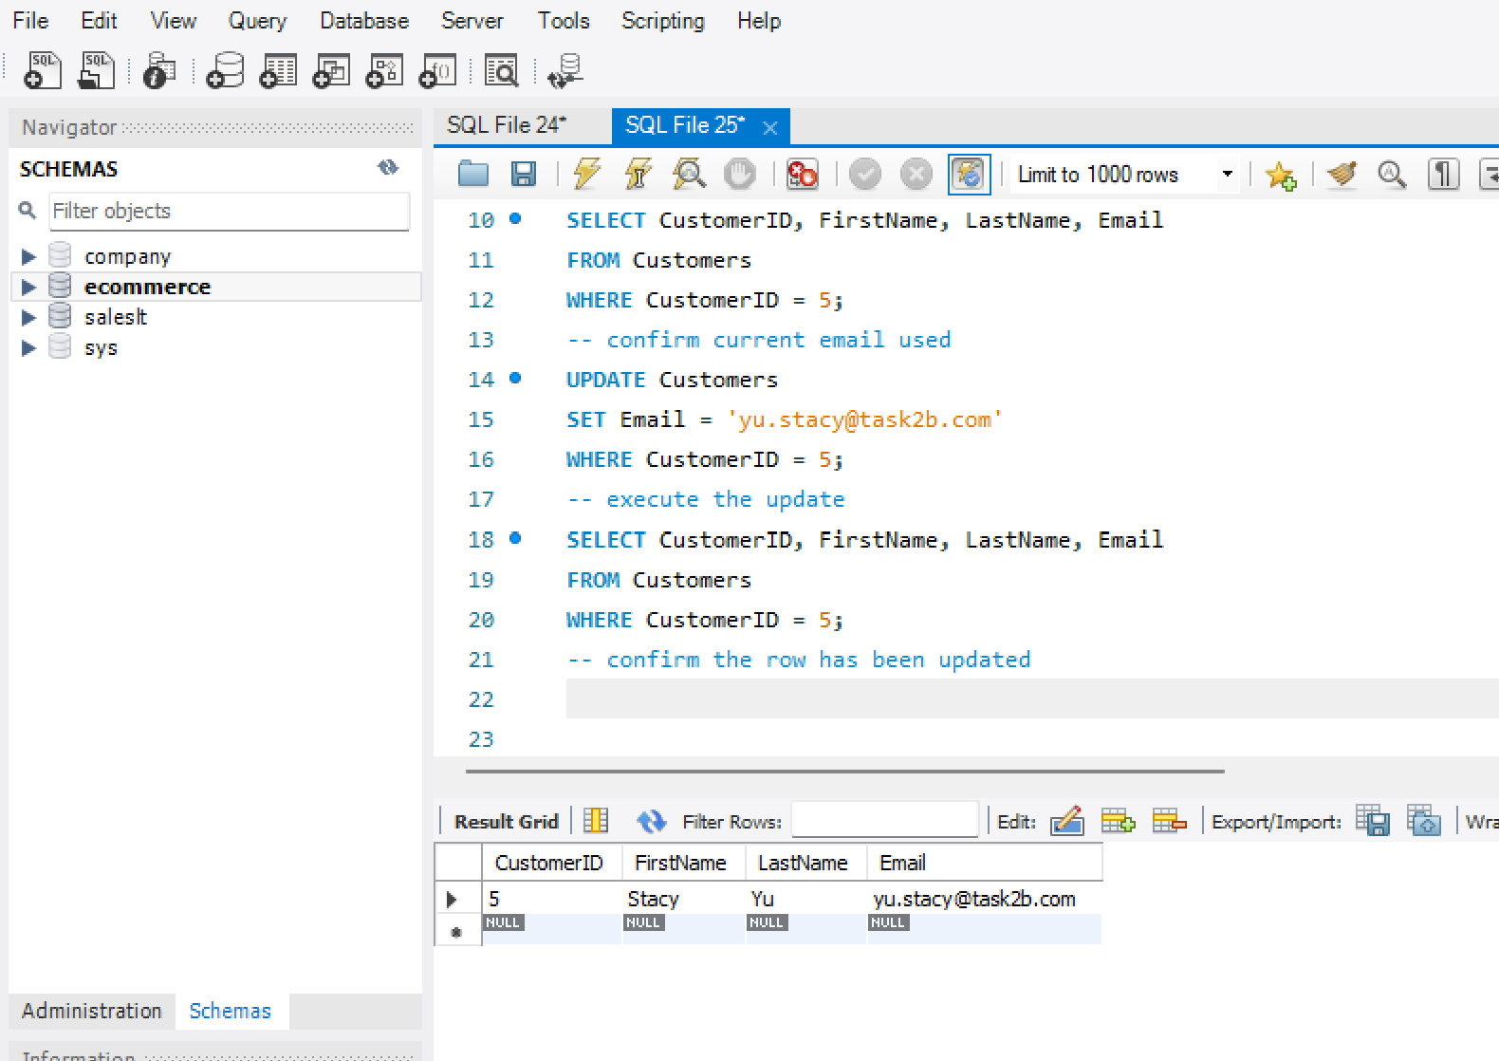

Delete a specific record from the Orders table based on OrderID.
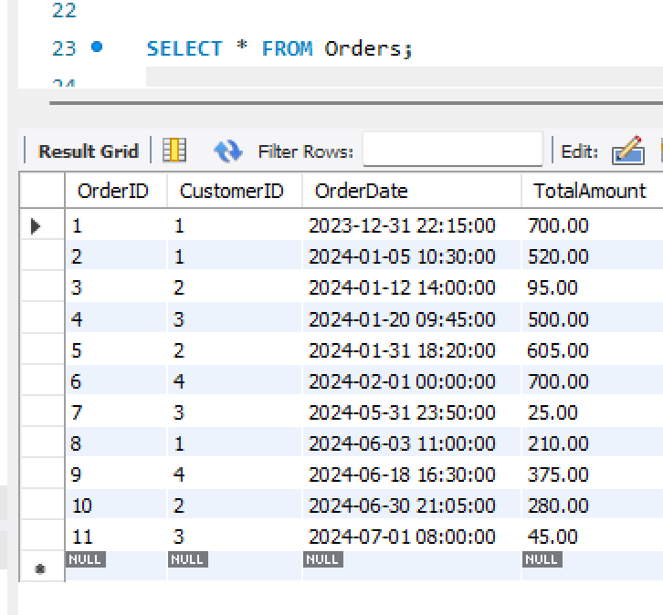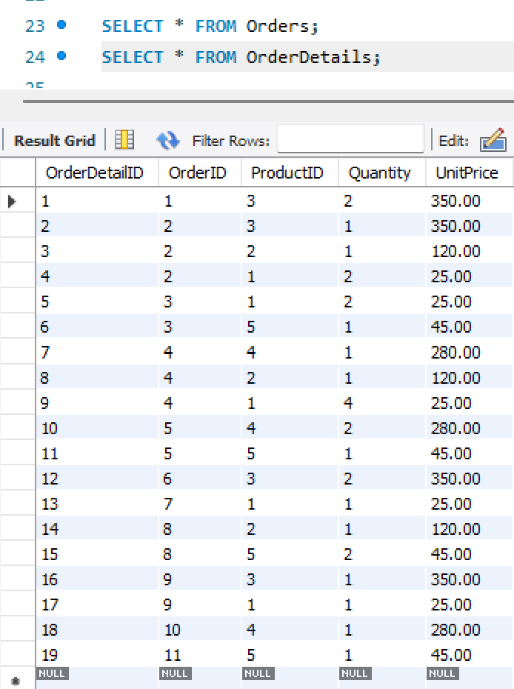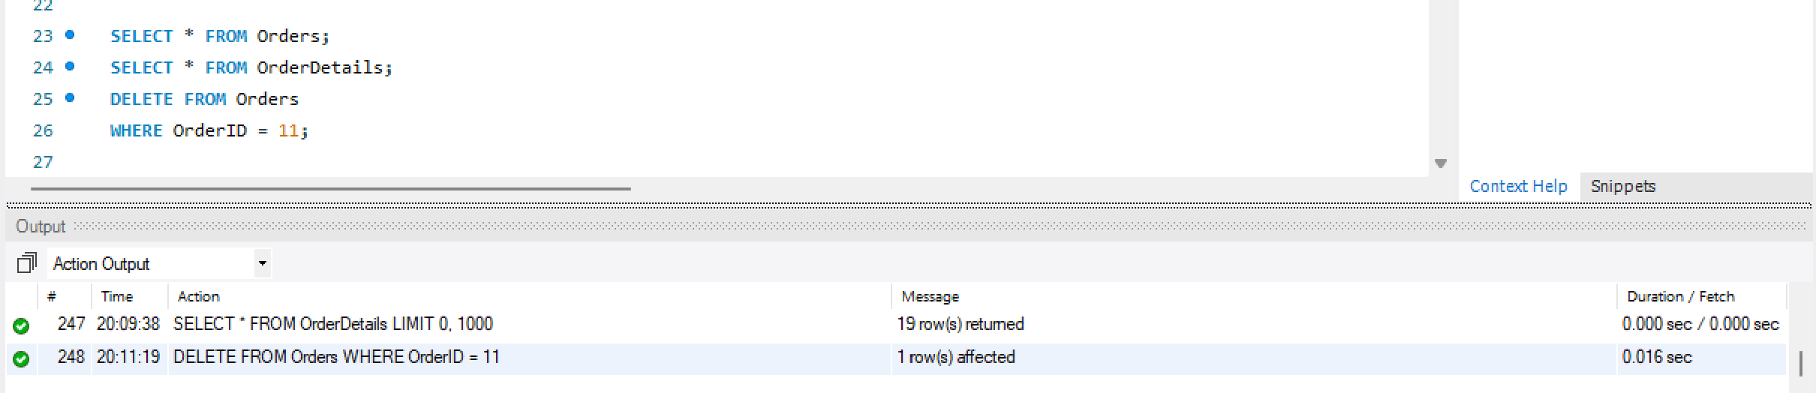
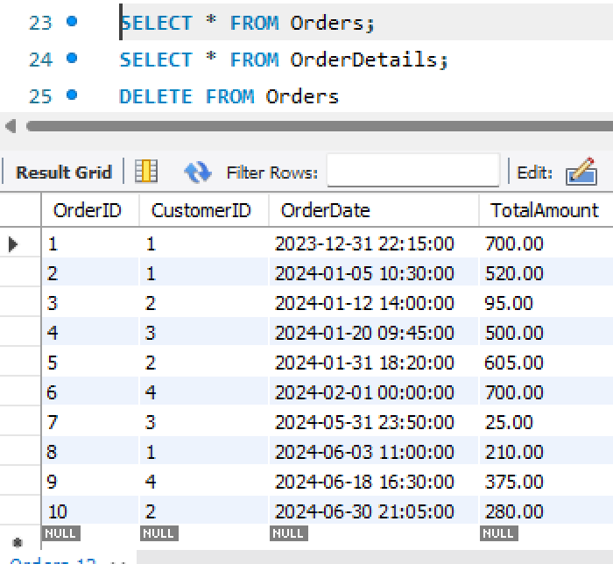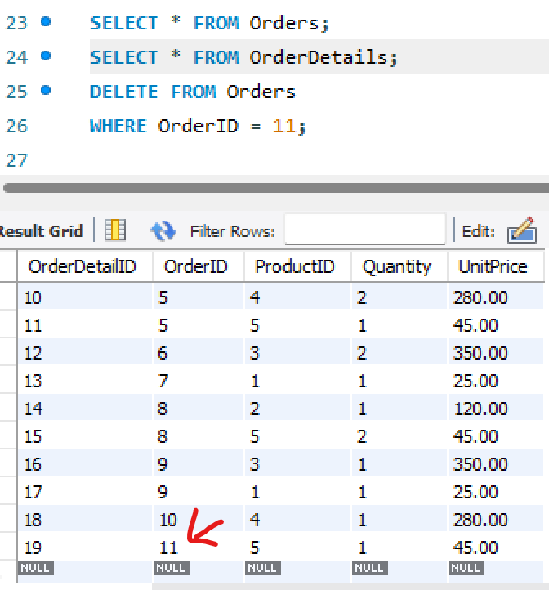
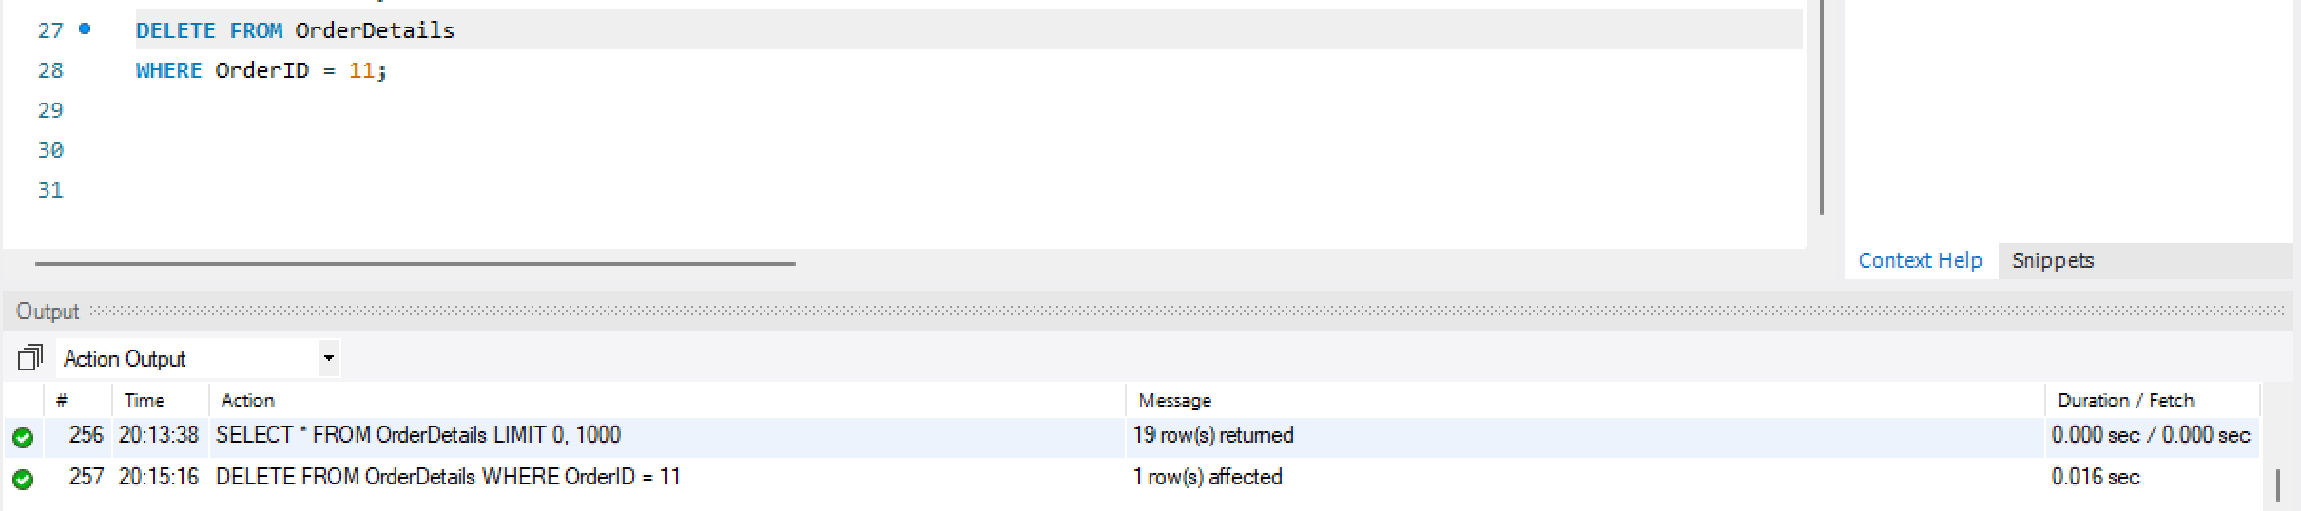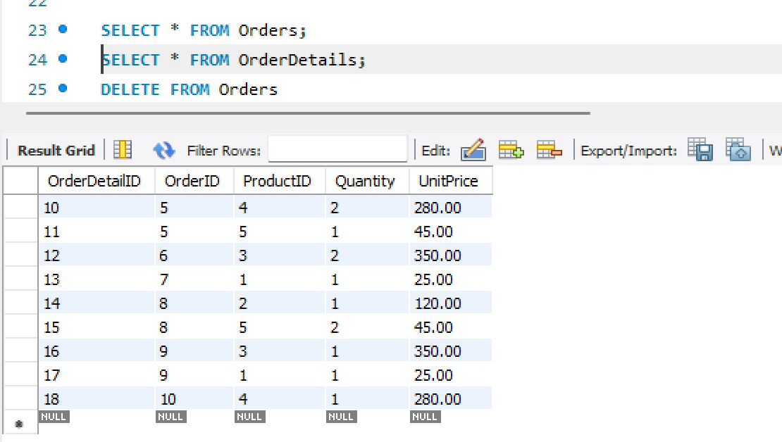

3. Advanced SELECT Queries: Filtered Data Retrieval (5 Marks)
Write a SELECT query to fetch all orders from the Orders table that meet the following criteria:
a) Orders were placed in January 2024.
b) The order total exceeds $500.
c) Your query should only include columns for OrderID, OrderDate, and TotalAmount in the result.
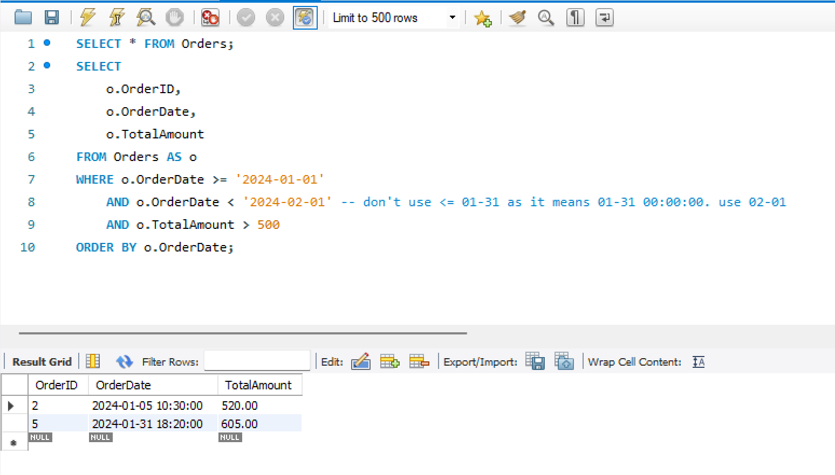

4. SQL Joins for Data Aggregation (5 Marks)
Retrieve Information Using Joins
a) Using the tables Products, Orders, and OrderDetails, write an SQL query.
b) The query should retrieve information on products ordered in June 2024.
c) The result should display:
ProductName: The name of the product.
QuantityOrdered: The quantity of each product in the order.
OrderDate: The date the order was placed.
